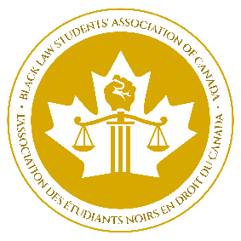

CIVIL LAW NEGOTIATION COMPETITION 2024
APPLICATION FORM

- Please complete one application form per participating school.

- Please submit the completed form electronically no later than 4:30 p.m. on Monday, November 20, 2023 to the National Francophone Director, Nadreyh Vagba at francophonedirector@blsacanada.com.

- Please pay the applicable registration fee through the Black Law Students Association of Canada website at blsacanada.com no later than 4:30 p.m. on Friday, November 24, 2022.

- Registration fee option A: $300 per team of 2
- Registration fee option B: $150 per team of 2
Please note that the registration fee for Option A includes contest registration, hotel accommodation for participants, participation in the welcome evening on Friday at the University of Ottawa Faculty of Law from 8 a.m. to 10 a.m., and food for participants during the contest. Option B registration fees include the same except for accommodation. The Francophone committee will contact teams at the close of registration to match them with a coach and remind them of the competition schedule. Teams will be contacted again in early January for further details on competition logistics.

INFORMATION ABOUT THE LAW FACULTY

Law Faculty:

Contact Person:

Phone number:

Law school mailing address:

STUDENT INFORMATION

Team 1

Full name:

Email address:

Phone number:

Full name:

Email address:

Phone number:

Team 2

Full name:

Email address:

Phone number:

Full name:

Email address:

Phone number:

SIGNATURES

Student #1
FULL NAME | SIGNATURE

Student #2
FULL NAME | SIGNATURE

Student #3
FULL NAME | SIGNATURE

Student #4
FULL NAME | SIGNATURE

Dean of the Faculty of Law
FULL NAME | SIGNATURE

